Supporting Materials for Data Validation
This file contains the data supporting the validation of the assembled conformations. Based on the Bandage-resolved mapping paths, we examined long-read coverage across each junction region (including ±500 bp flanking each junction). In the IGV screenshots, the red-boxed area in the coverage track indicates the approximate position of each junction.

Camellia lanceoleosa (diploid)
#rname | startpos | endpos | numreads | covbases | coverage | meandepth
contig3 | 145796 | 146796 | 59 | 1001 | 100 | 45.1029
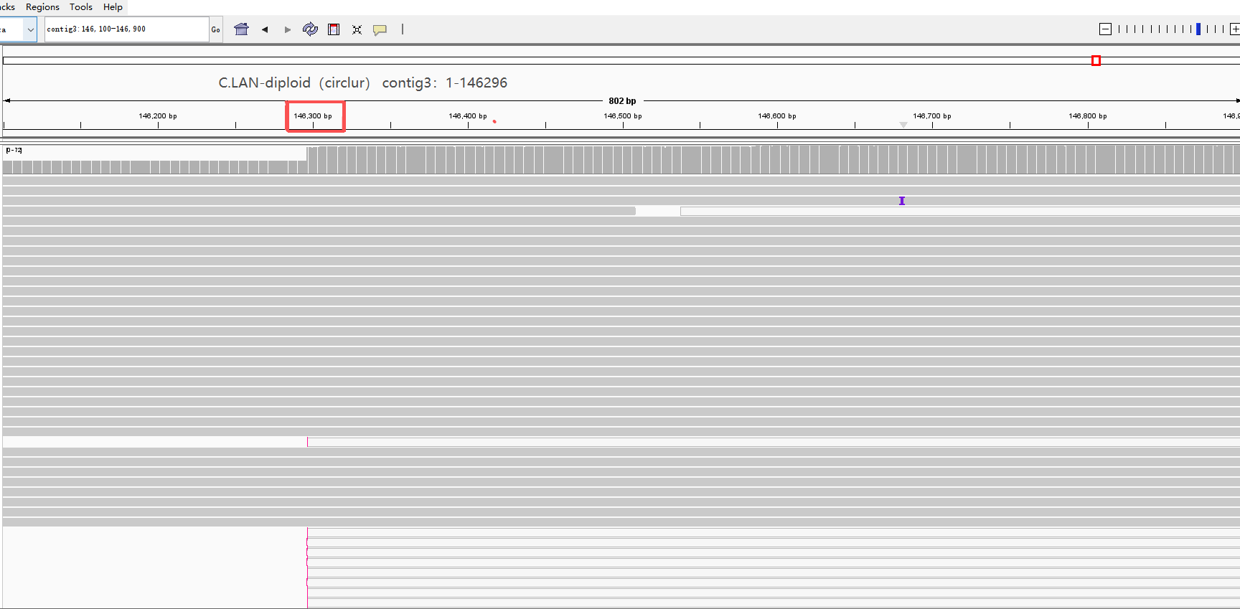

#rname | startpos | endpos | numreads | covbases | coverage | meandepth
contig4-2 | 239809 | 240809 | 76 | 1001 | 100 | 48.5415
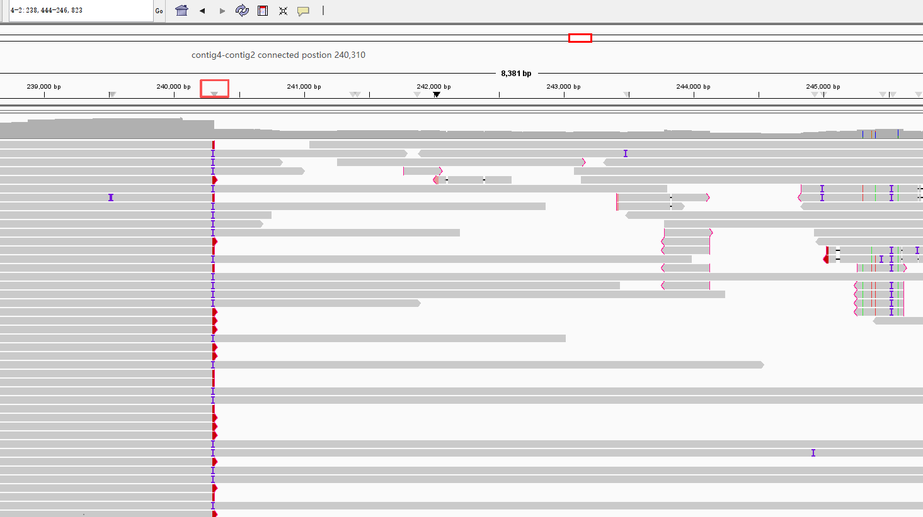
#rname | startpos | endpos | numreads | covbases | coverage | meandepth
contig1 | 352799 | 353799 | 59 | 1001 | 100 | 51.4995
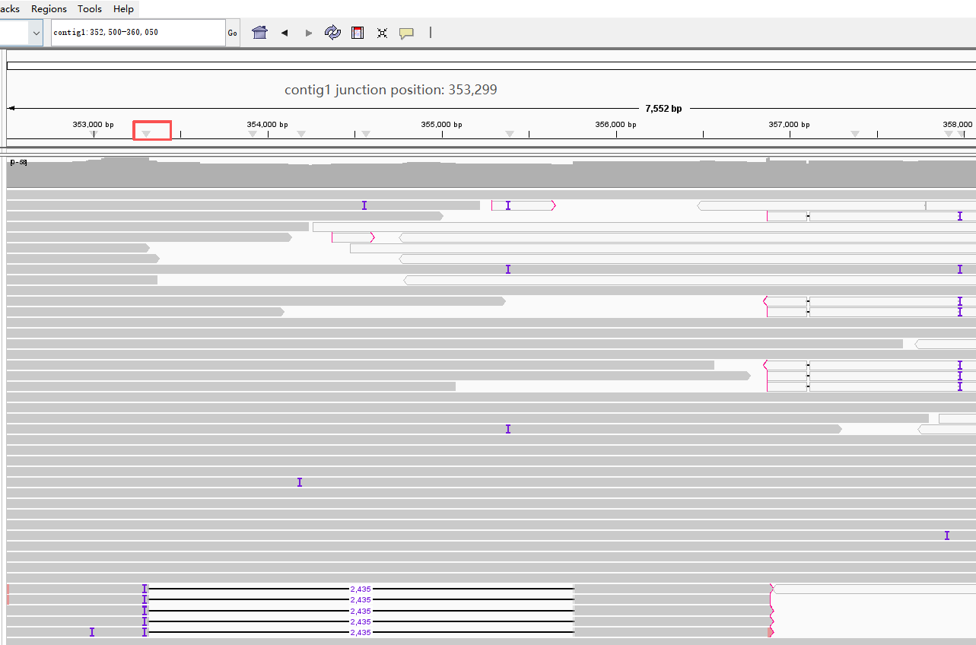

#rname | startpos | endpos | numreads | covbases | coverage | meandepth
contig4-3 | 239809 | 240809 | 74 | 1001 | 100 | 52.98

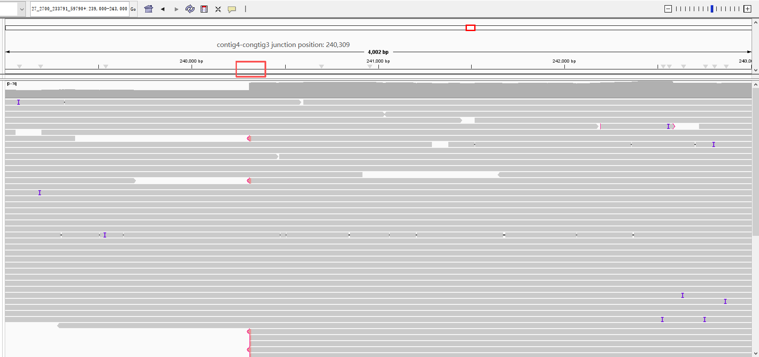

Camellia oleifera 'HuaShuo' (hexaploid)
#rname | startpos | endpos | numreads | covbases | coverage | meandepth
contig1 | 93624 | 94624 | 175 | 1001 | 100 | 97.3936

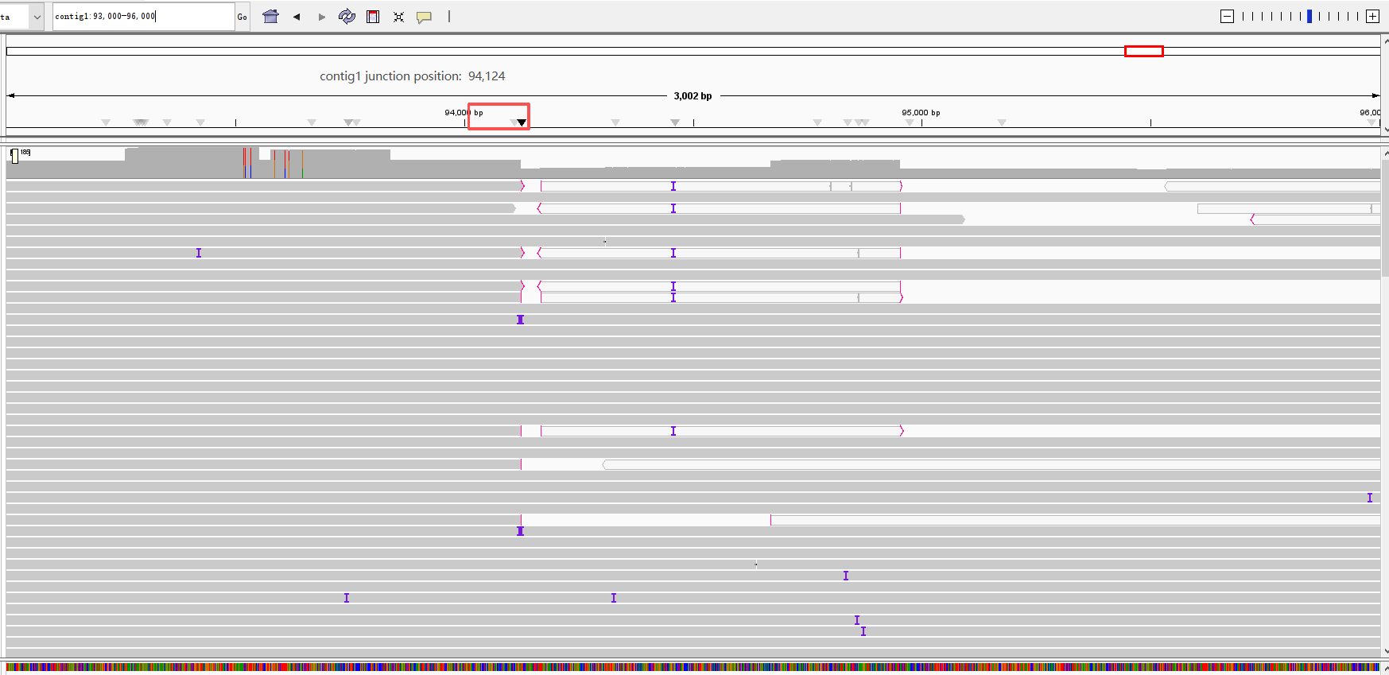

#rname | startpos | endpos | numreads | covbases | coverage | meandepth
contig4-2 | 174333 | 175333 | 130 | 1001 | 100 | 102.813
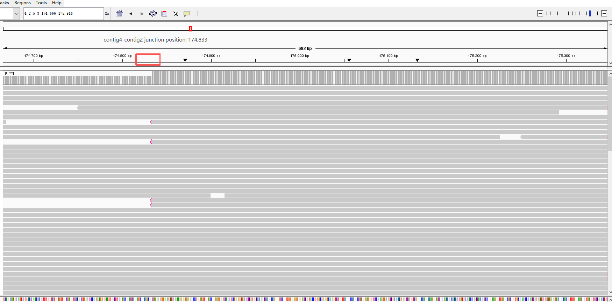

#rname | startpos | endpos | numreads | covbases | coverage | meandepth
contig2-5 | 405994 | 406994 | 86 | 1001 | 100 | 63.4585
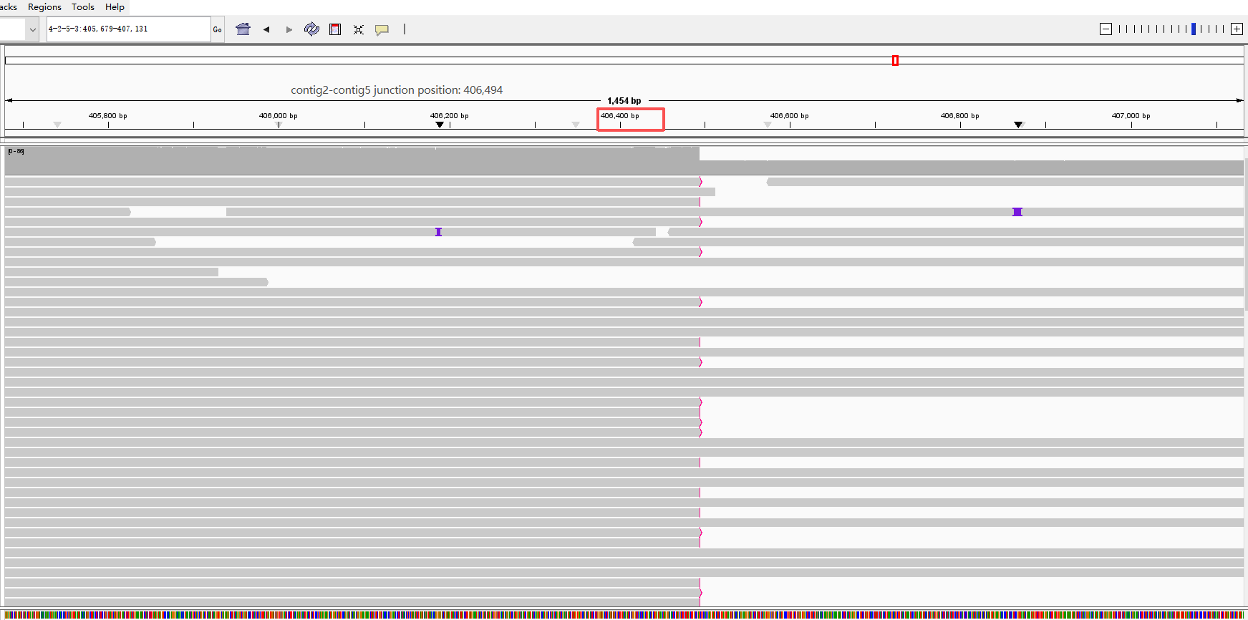

#rname | startpos | endpos | numreads | covbases | coverage | meandepth
contig5-3 | 480434 | 481434 | 94 | 1001 | 100 | 65.5185
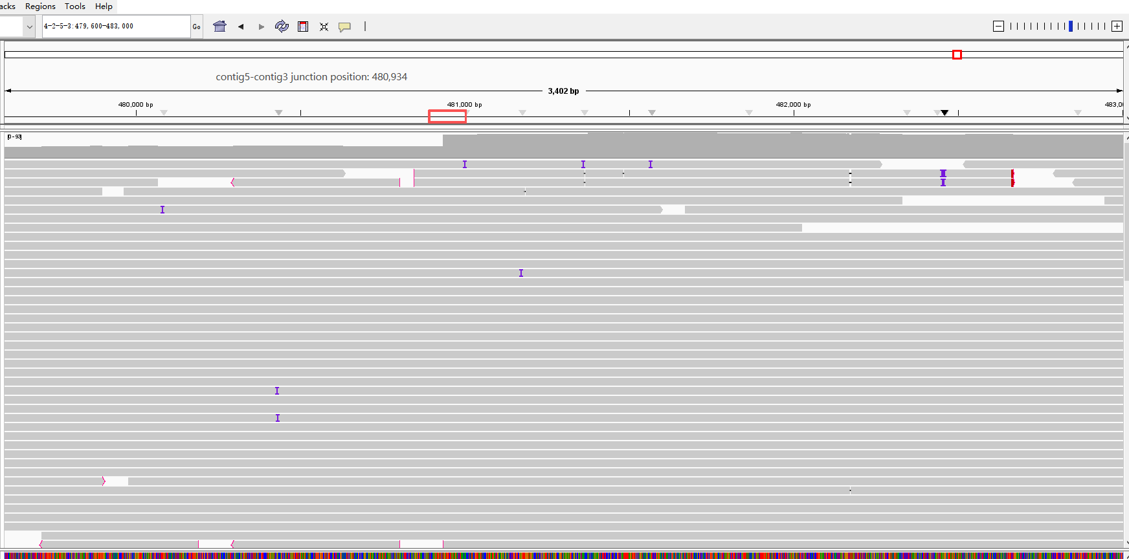

#rname | startpos | endpos | numreads | covbases | coverage | meandepth
contig4-3 | 174333 | 175333 | 100 | 1001 | 100 | 75.7463
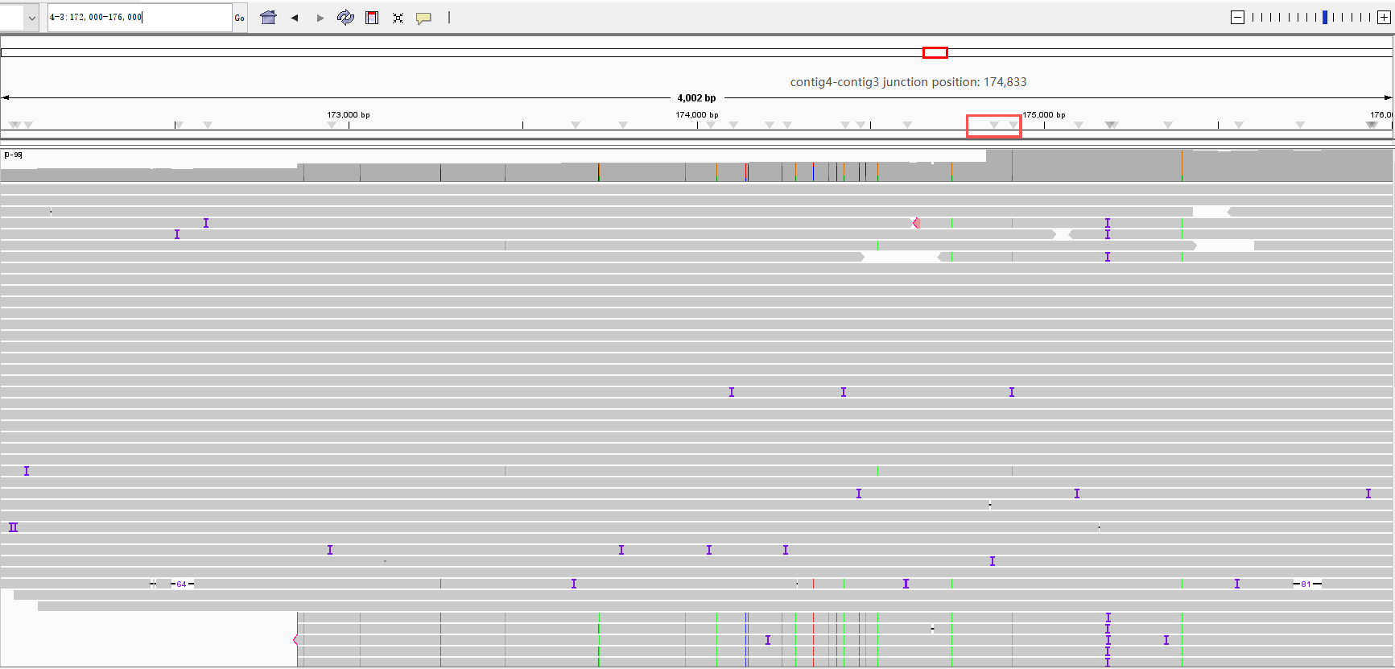

#rname | startpos | endpos | numreads | covbases | coverage | meandepth
contig2-6 | 231161 | 232161 | 91 | 994 | 99.3007 | 87.2897
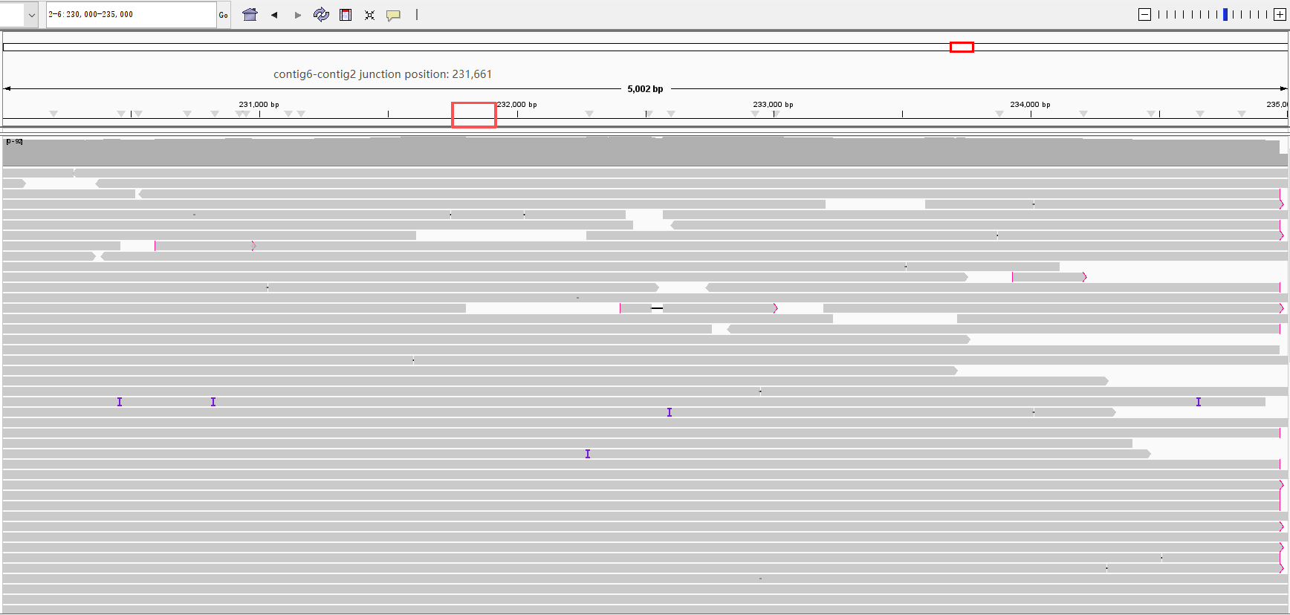

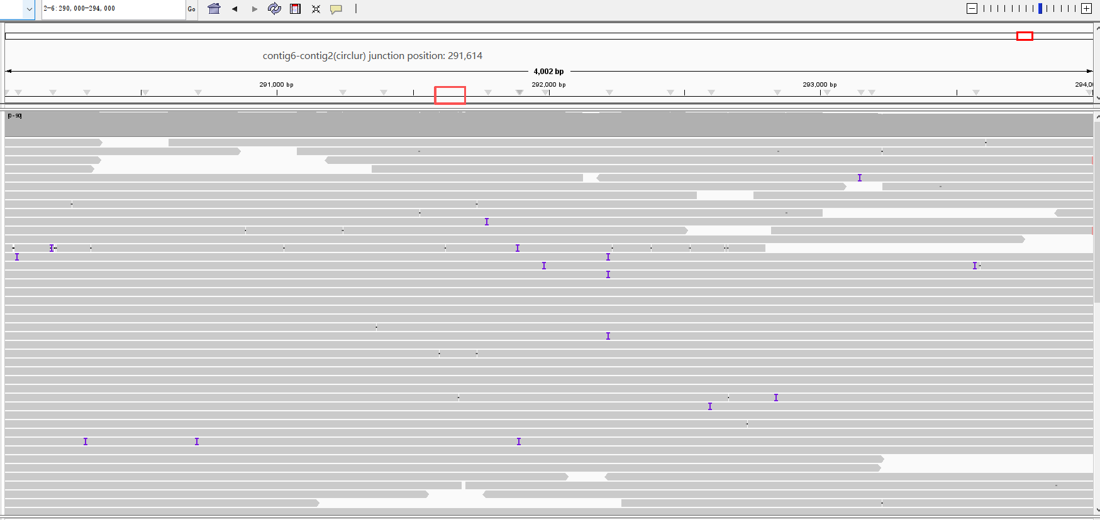

Camellia oleifera var. 'Nanyongensis' (diploid)
#rname | startpos | endpos | numreads | covbases | coverage | meandepth
contig7-2 | 123742 | 124742 | 291 | 1001 | 100 | 212.458
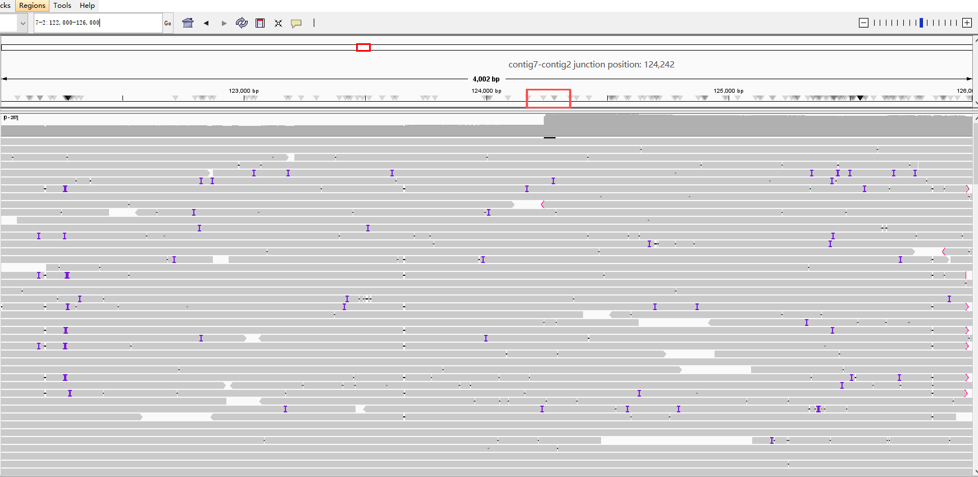

#rname | startpos | endpos | numreads | covbases | coverage | meandepth
contig1 | 352794 | 353794 | 285 | 1001 | 100 | 207.241
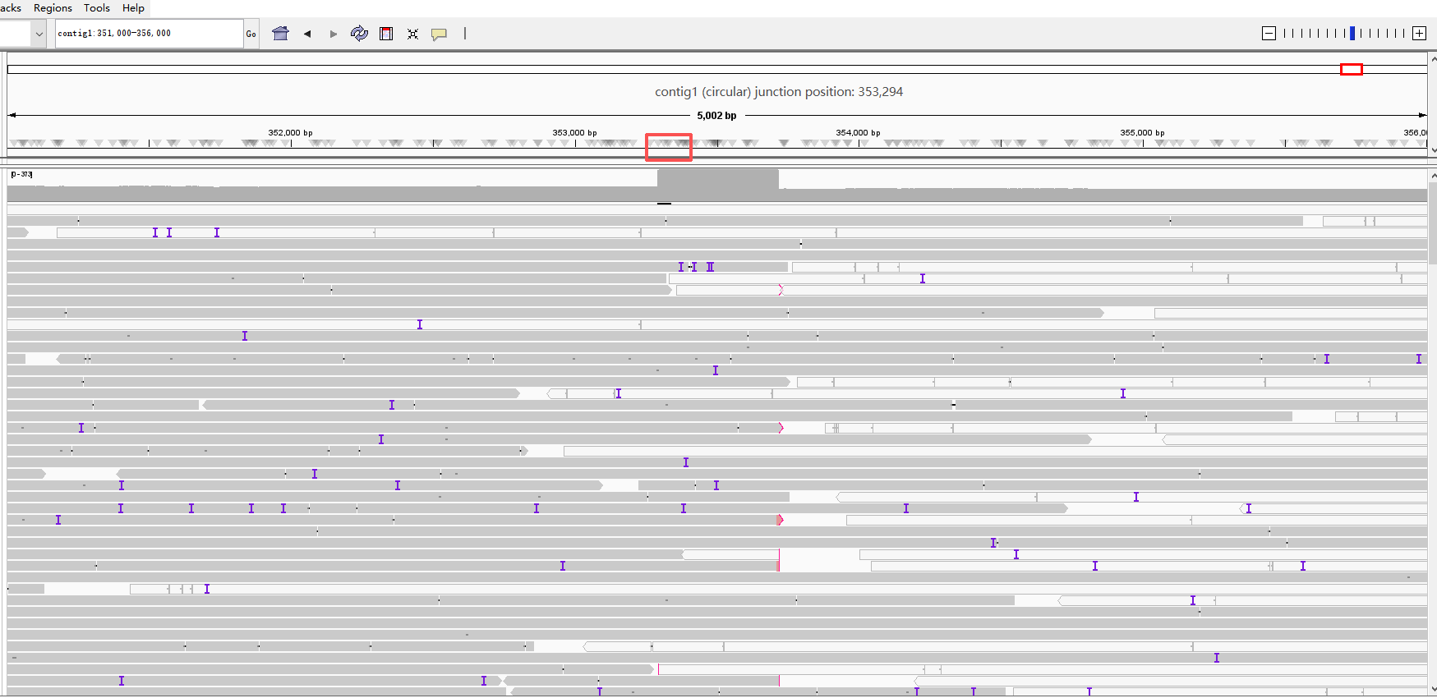

#rname | startpos | endpos | numreads | covbases | coverage | meandepth
contig6-7 | 60836 | 61836 | 319 | 1001 | 100 | 226.262
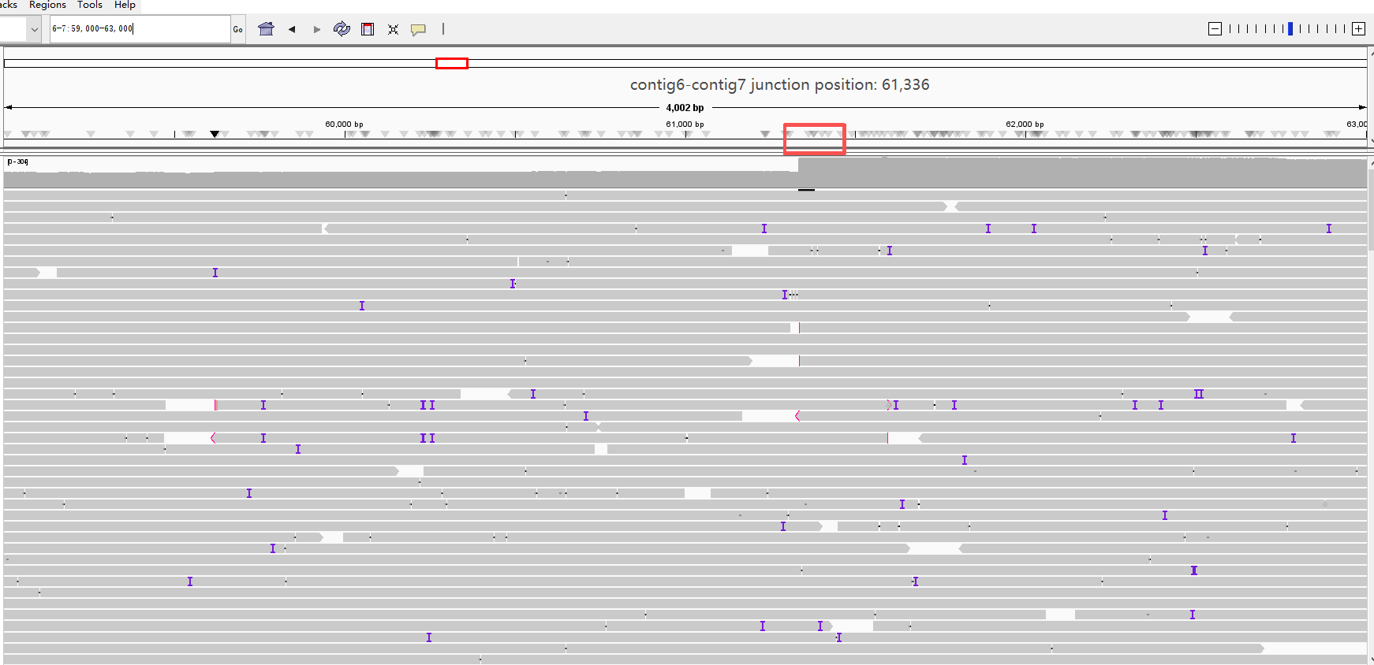

#rname | startpos | endpos | numreads | covbases | coverage | meandepth
contig5-7 | 114640 | 115640 | 307 | 1001 | 100 | 219.116
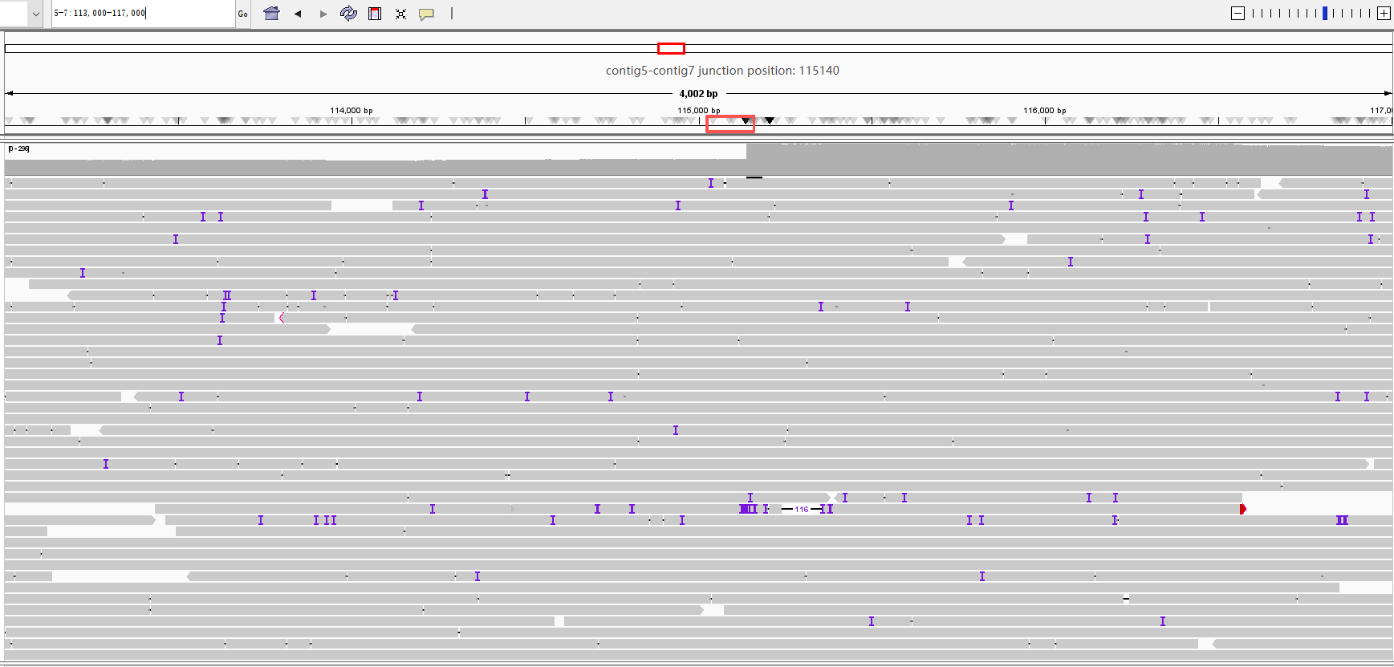

#rname | startpos | endpos | numreads | covbases | coverage | meandepth
contig5-3 | 114640 | 115640 | 290 | 1001 | 100 | 202.122
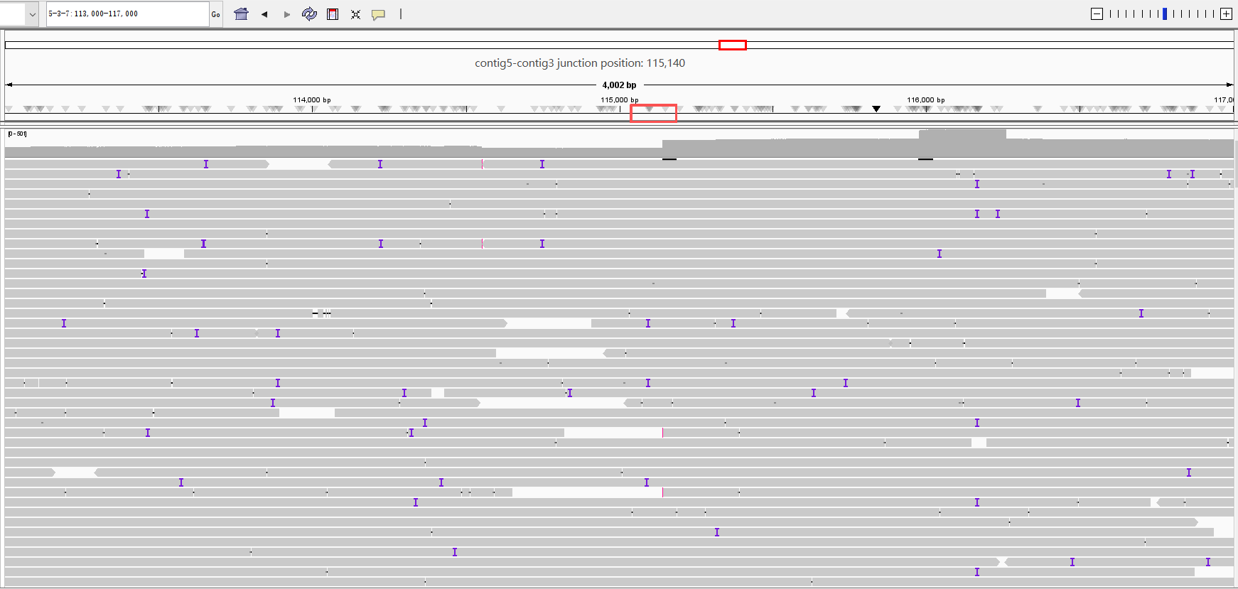

#rname | startpos | endpos | numreads | covbases | coverage | meandepth
contig3-7 | 132390 | 133390 | 279 | 1001 | 100 | 263.548
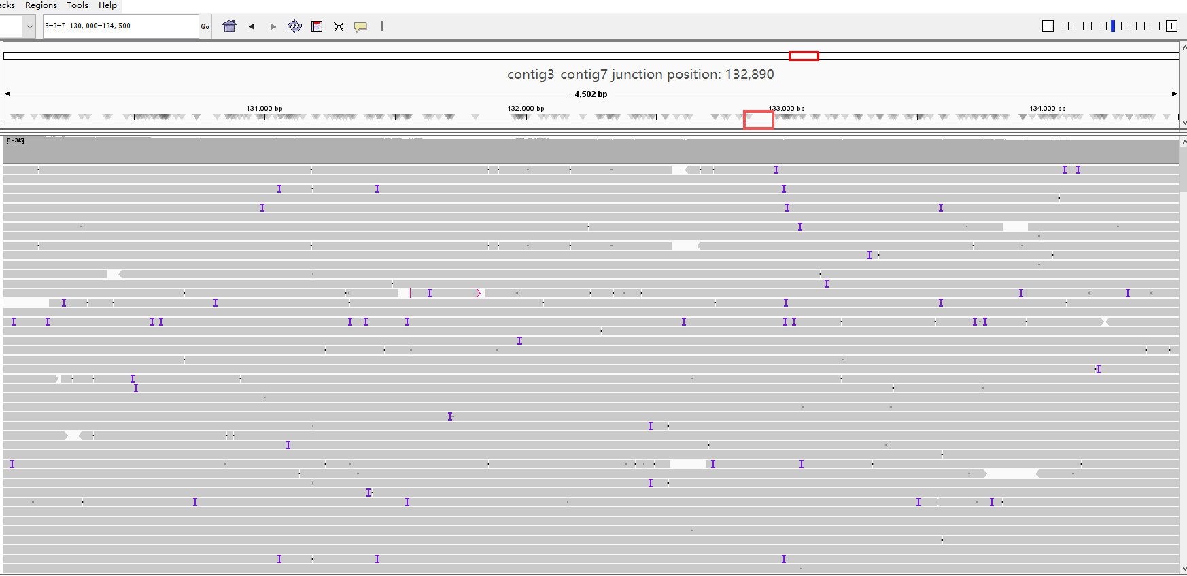

#rname | startpos | endpos | numreads | covbases | coverage | meandepth
contig4-3 | 36164 | 37164 | 294 | 1001 | 100 | 210.187
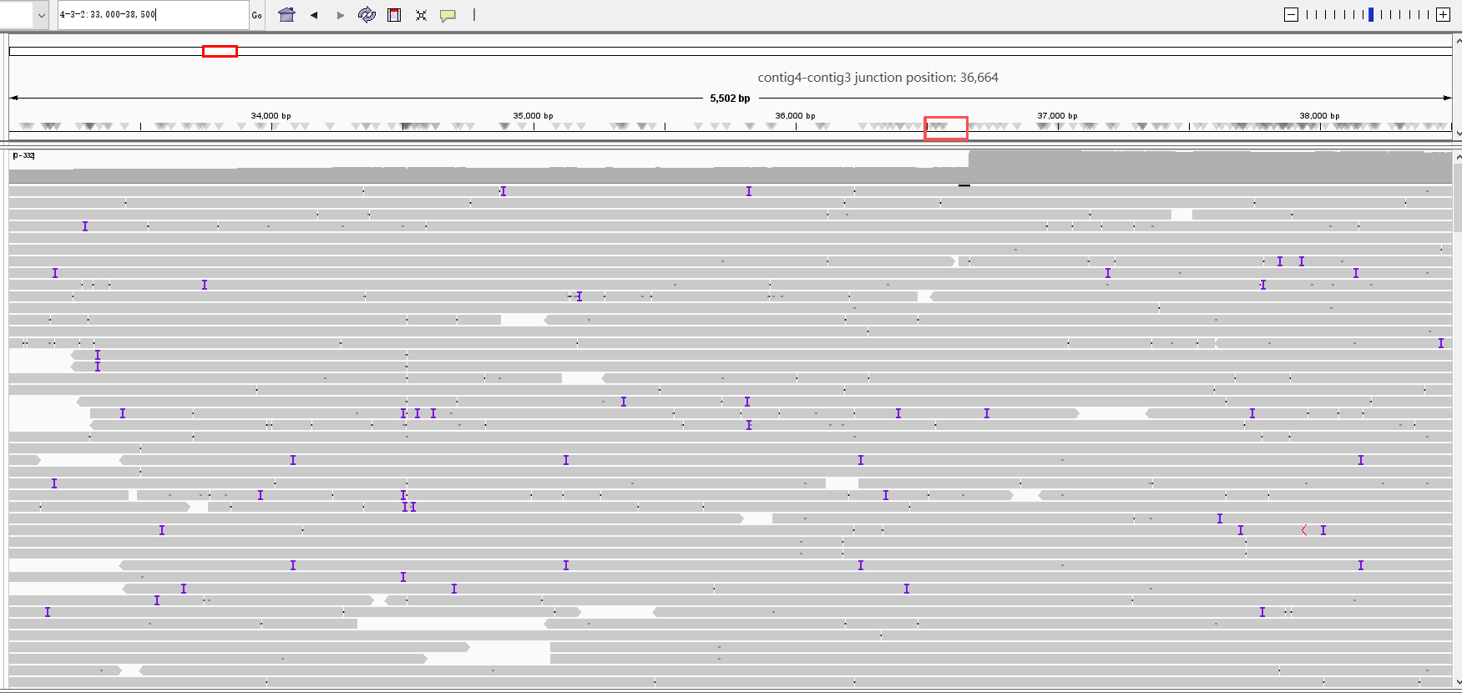

#rname | startpos | endpos | numreads | covbases | coverage | meandepth
contig3-2 | 53914 | 54914 | 181 | 1001 | 100 | 167.253
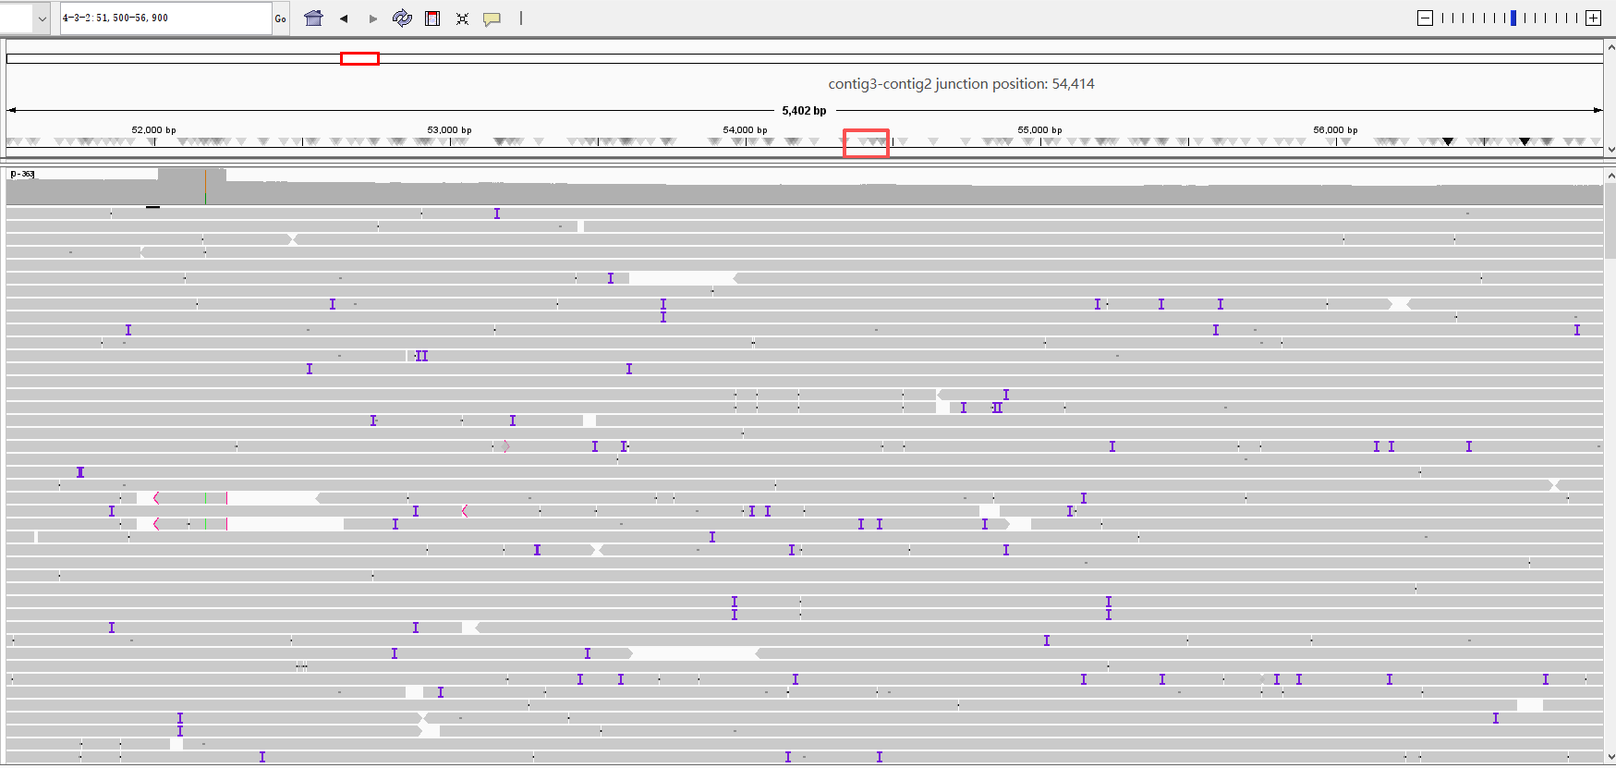

Camellia meiocarpa Hu (synonym: Camellia oleifera) (tetraploid)
#rname | startpos | endpos | numreads | covbases | coverage | meandepth
contig2-1 | 117700 | 118700 | 639 | 1001 | 100 | 468.46
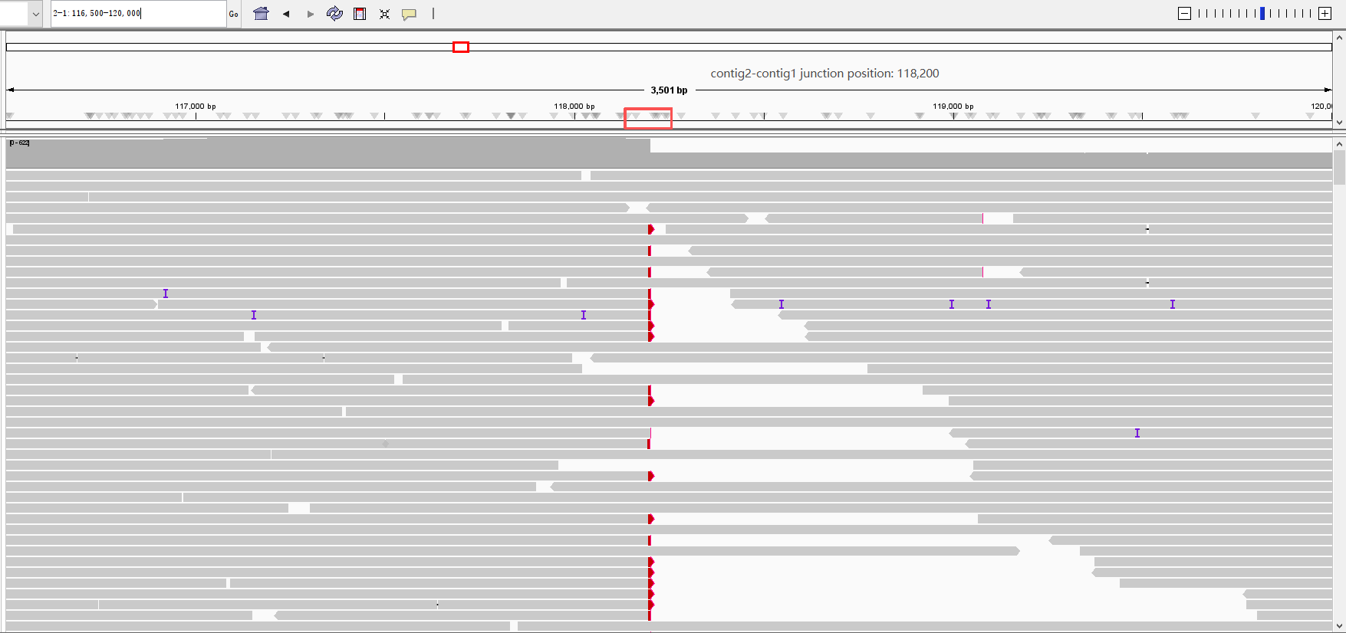

#rname | startpos | endpos | numreads | covbases | coverage | meandepth
contig5-6 | 234210 | 235210 | 468 | 1001 | 100 | 330.835
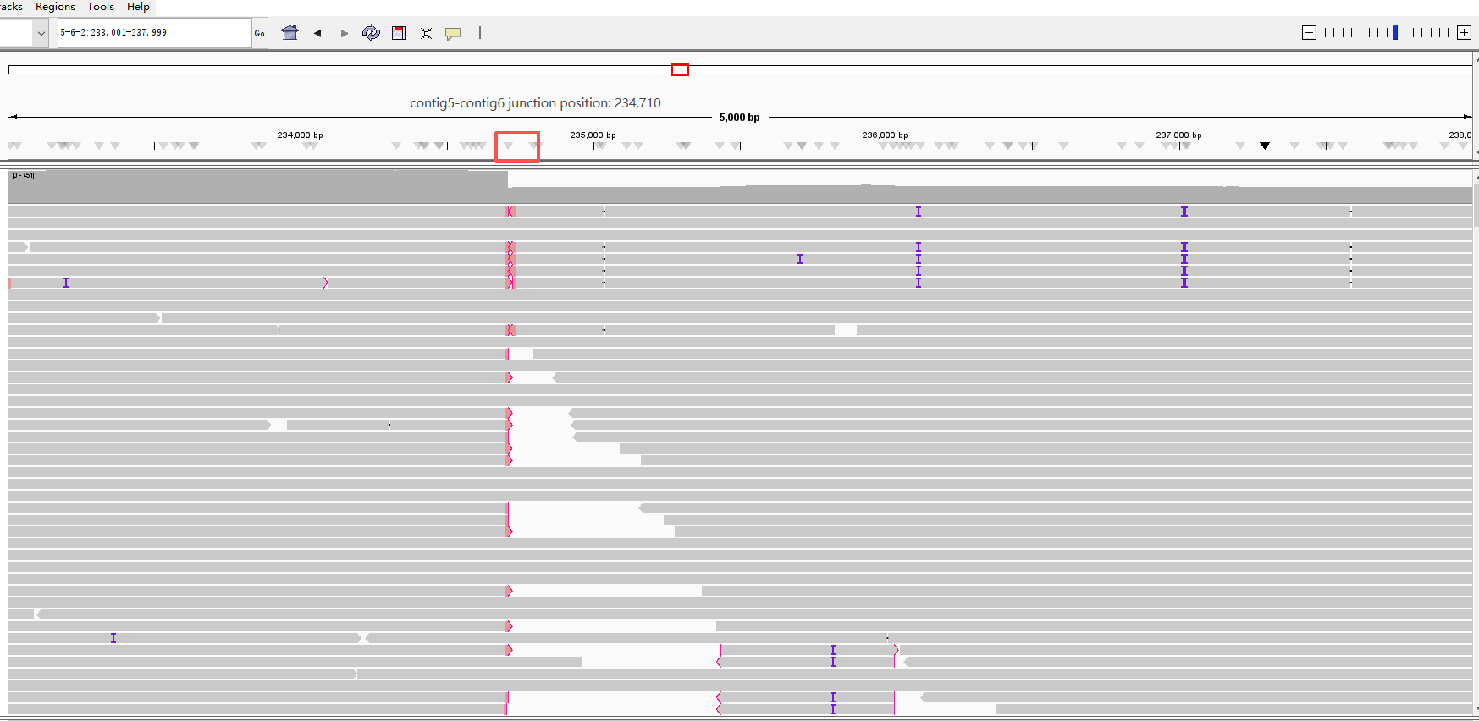

#rname | startpos | endpos | numreads | covbases | coverage | meandepth
contig6-2 | 394618 | 395618 | 489 | 1001 | 100 | 347.686
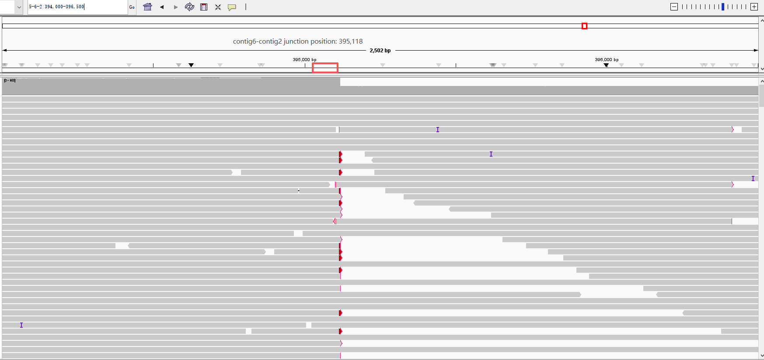

#rname | startpos | endpos | numreads | covbases | coverage | meandepth
contig6-3 | 159908 | 160908 | 533 | 1001 | 100 | 360.993
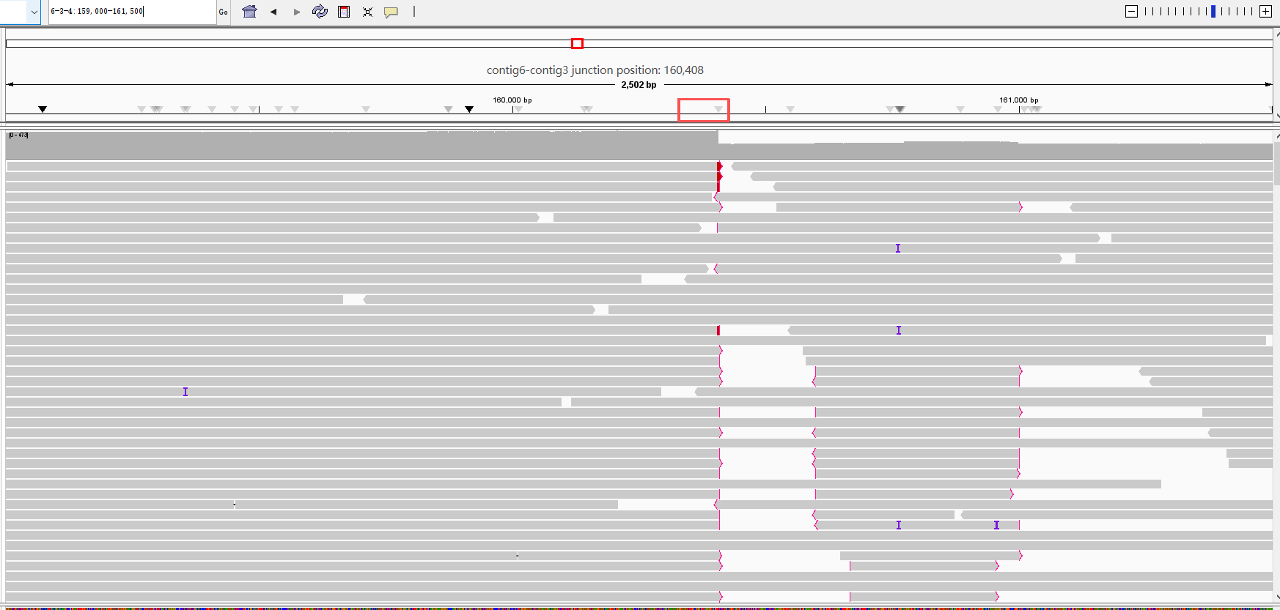

#rname | startpos | endpos | numreads | covbases | coverage | meandepth
contig3-4 | 267820 | 268820 | 511 | 1001 | 100 | 372.167
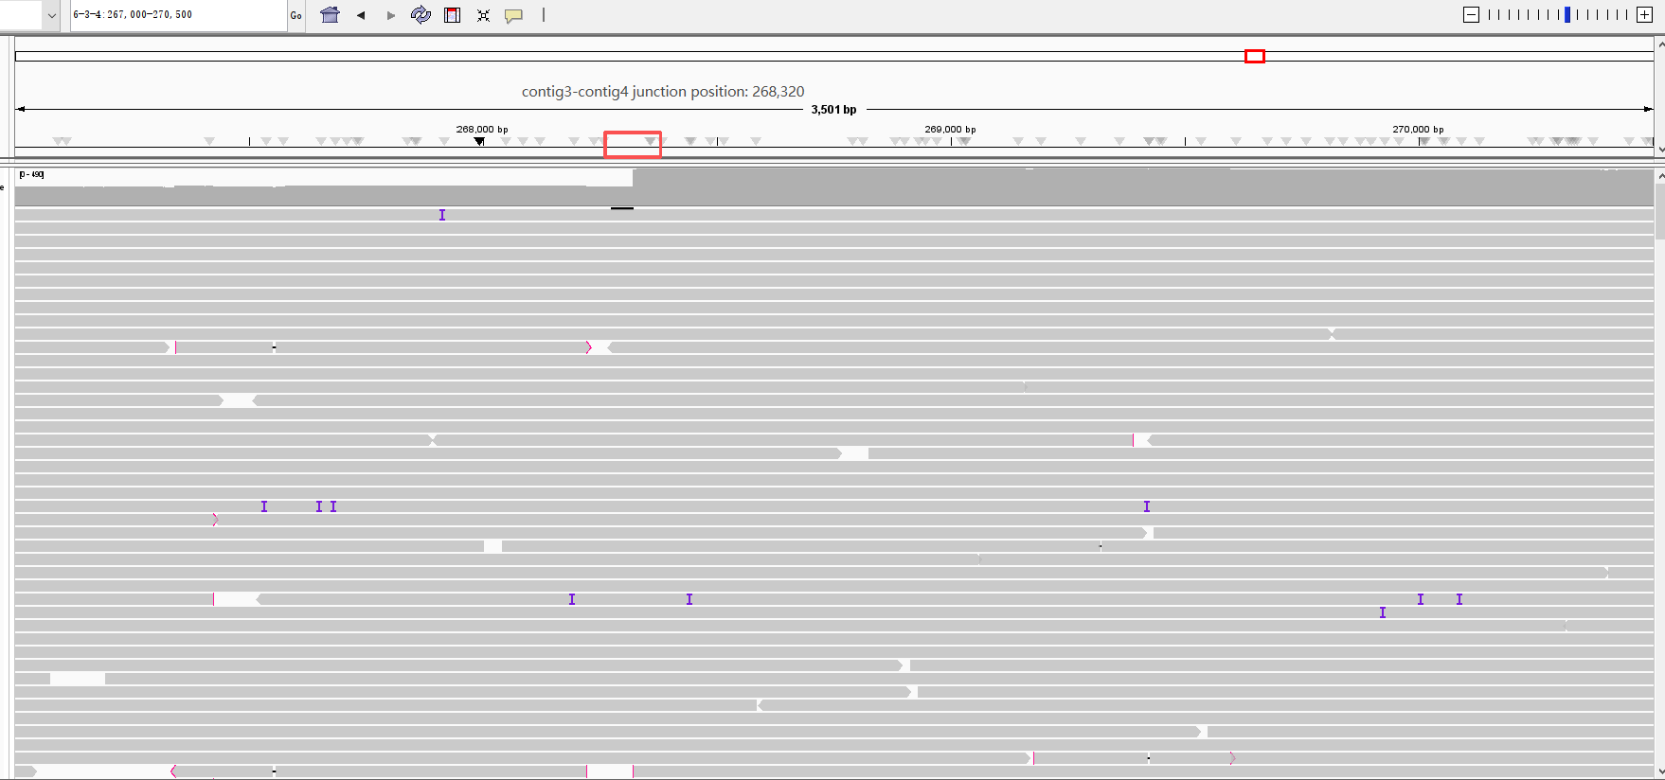

#rname | startpos | endpos | numreads | covbases | coverage | meandepth
contig4 | 86348 | 87348 | 373 | 1001 | 100 | 291.201
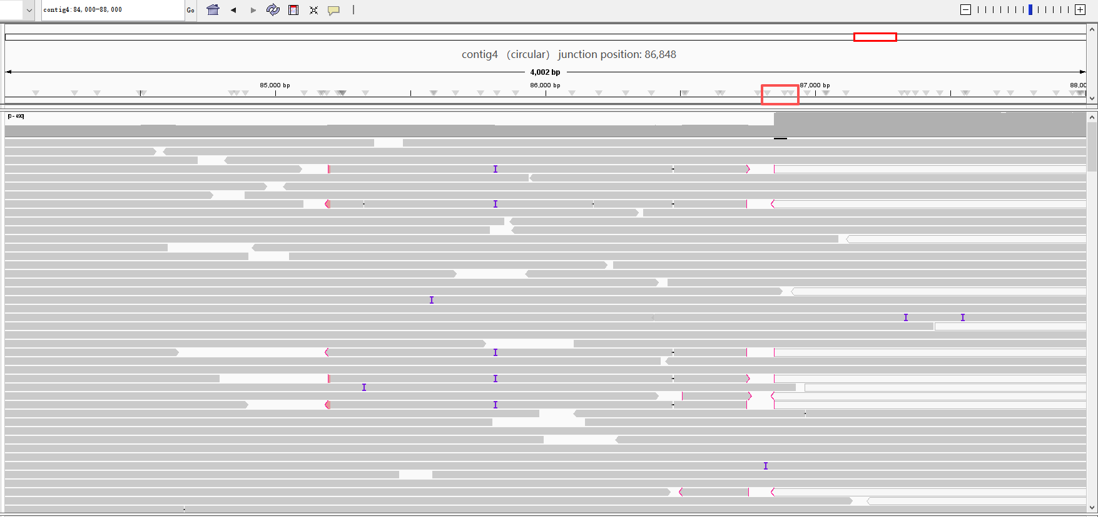

#rname | startpos | endpos | numreads | covbases | coverage | meandepth
contig5 | 234210 | 235210 | 456 | 1001 | 100 | 335.536
